**Assignment 4.2**

Problem​ ​Statement​ ​1:

Write a Python program using function concept that maps list of words into a list of integers

representing the lengths of the corresponding words.

Hint:​ ​If a list [ ab,cde,erty] is passed on to the python function output should come as [2,3,4]

Here 2,3 and 4 are the lengths of the words in the list.

**Solution:**

def word_lenght(findlist):

word_len = []

for n in findlist:

word_len.append((len(n)))

word_len.sort()

return word_len[0],word_len[1],word_len[2]

print(word_lenght(["ab", "cde", "erty"]))

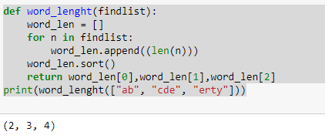

Or

listlength = ["ab", "cde", "erty"]

Newl = [len(x) for x in listlength]

print(Newl)

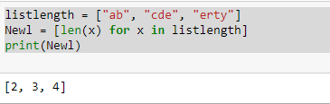

**Problem​ ​Statement​ ​2:**

Write a Python function which takes a character (i.e. a string of length 1) and returns True if it is

A vowel, False otherwise.

**Solution:**

def is_vowel(char):

vowels = ('a', 'e', 'i', 'o', 'u')

if char not in vowels:

return False

return True

print (is_vowel('a'))

